**Pandas Exercise**

* **Question 1: From given data set print first and last five rows:**

Expected Output:

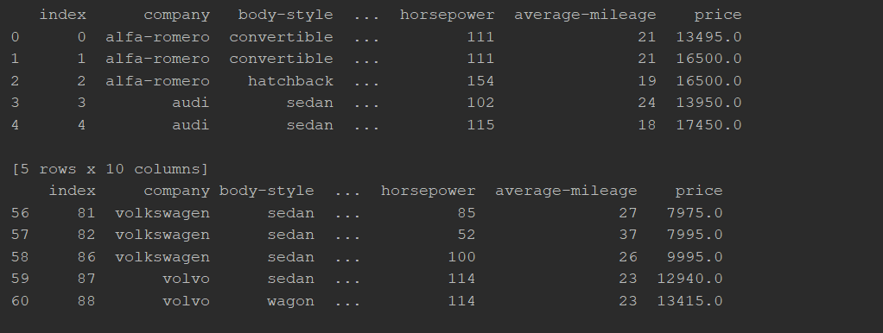

### Question 2: Clean data and update the CSV file

Replace all column values which contain ‘?’ and n.a with NaN.

### Question 3: Find the most expensive car company name

Print most expensive car’s company name and price.

Expected Output:

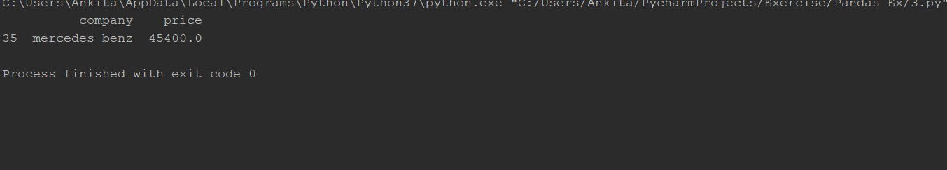

### Question 4: Print All Toyota Cars details

Expected Output:

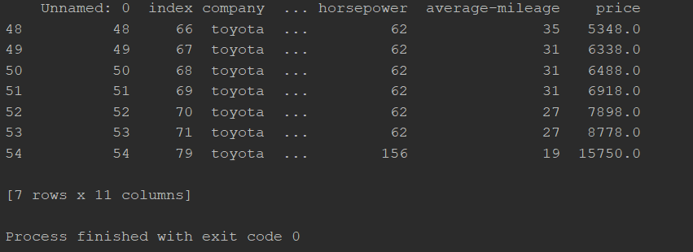

### Question 5: Count total cars per company

Expected Outcome:

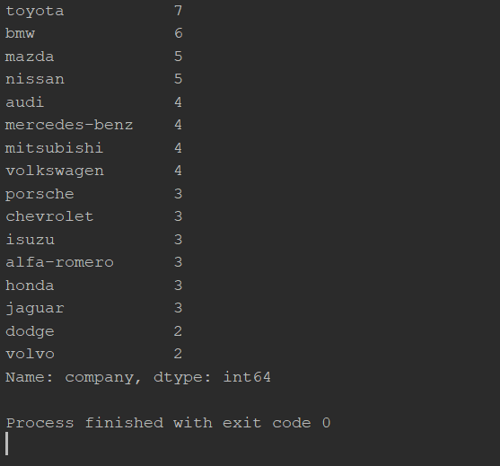

### Question 6: Find each company’s Highest price car

Expected Outcome:

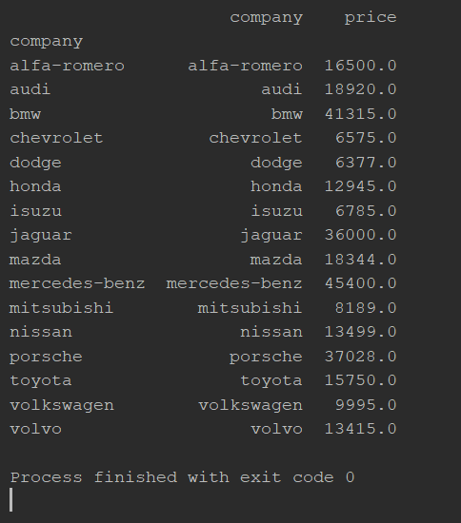

### Question 7: Find the average mileage of each car making company

Expected Output:

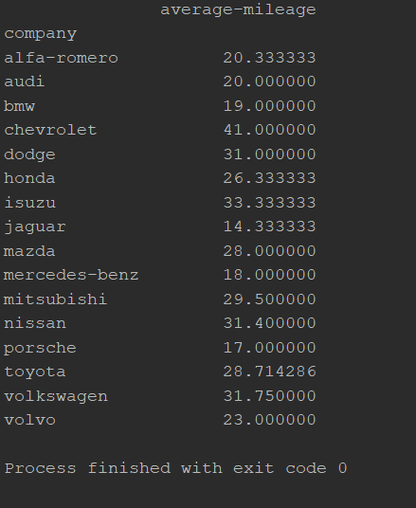

### Question 8: Sort all cars by Price in descending order column and display first five rows:

Expected Output:

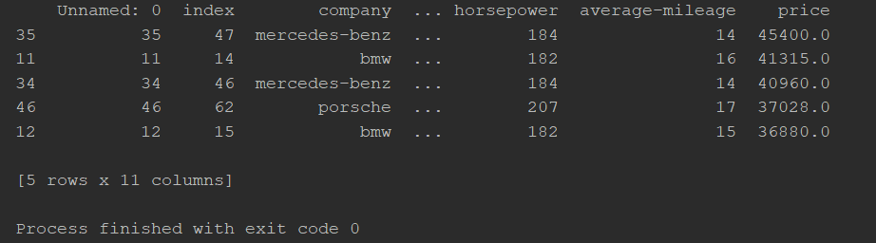

### Question 9: Concatenate two data frames using the following conditions

Create two data frames using the following two Dictionaries, Concatenate those two data frames and create a key for each data frame.



Expected Output:

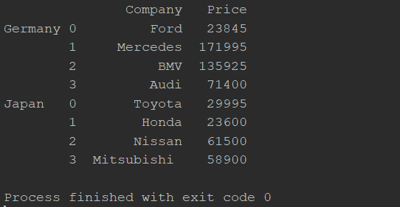

### Question 10: Merge two data frames using the following condition

Create two data frames using the following two Dictionaries, Merge two data frames, and append second data frame as a new column to the first data frame.

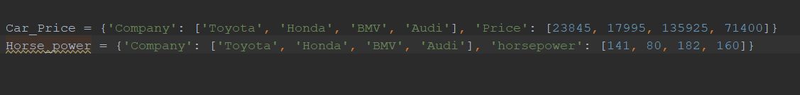

Expected Output:

